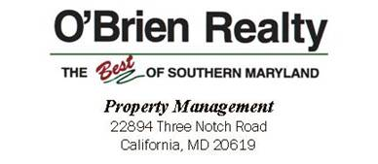

***301-863-2400 ext. 241 or 1- 800-876-2444***

***E-mail: jimmy.hayden@obrienrealty.com***



**Move-Out Requirements**

***Property Management***

Move-out inspection of rental properties are made between 8AM-4PM Monday thru Friday but not later than the Friday before the lease ends when possible. All of your furniture and personal items must be removed from the rental and keys turned in before an inspection can be made. You may not stay in the property after the inspection is completed.

1. Remove all personal items and trash from the dwelling and property.
2. Clean appliances thoroughly as they would be ready for your use! Make em shine!
3. Clean cabinets and apply furniture polish as needed on woodwork.
4. Clean sinks and inside all of cabinets.
5. Have carpets PROFESSIONALLY cleaned and provide copy of receipt to PM office.
6. Make sure all walls are wiped clean and no nails or nail holes visible.
7. Clean windows and ensure all screens are in place. Repair any screen damaged.
8. Clean and disinfect bathrooms thoroughly.
9. Lawn should be mowed and trimmed no more than 5 days before vacating.
10. Make any necessary repairs caused by you or any pets.
11. Discontinue utilities, ie. gas, electric, etc. service to end the day you’re vacating.
12. Please make sure your garbage service is not turned off prior to vacating as no garbage or refuse can be left at the property.
13. The fireplace and/or chimney must be PROFESSIONALLY cleaned and receipt provided to PM office.
14. If tenant fails to pass the 1st Move Out Inspection of the rental unit and requests time to correct, a $25 re-inspection fee will be charged and will be deducted from tenant’s security deposit if not paid in advance.
15. Please return all keys and remotes at time of inspection. If keys or remotes are not turned in during move out inspection, a $75 charge will be applied or deducted from tenant’s security deposit. Some remotes, ie. gas fireplace, are over $200 and will be charged actual amount of replacement.

Our goal is to have a great relationship with our tenant keeping our landlords property in top shape protecting their investment. Leaving things for Property Management to take care of will be more expensive to you. Your cooperation is greatly appreciated.

Sign here stating you have read and understand this document _____________Date:_________